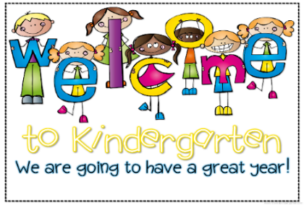
Bancroft School

Kindergarten Supply List
2023-2024

Dear Kindergarten Parents,

Another wonderful school year is coming to an end and we are now beginning to prepare the 2023-2024 school year. We hope you are looking forward to your child’s start in Kindergarten. Below you will find the required school materials and other useful, much needed and appreciated items to allow for continual proper hygiene and extra care in the classroom.
All other classroom supplies such as duo-tangs duo-tangs copybooks are pre-ordered by the classroom teachers.

- 1 large/big sturdy school bag
(Not a small daycare backpack. It must be able to fit a school agenda, their lunch box, and other books/workbooks they will take home throughout the year).
- 1 lunch box
- 1 child-sized YOGA mat (no blankets or folding sleeping mats)

- A change of clothing in a clearly labeled Ziploc Bag
(t-shirt, pants, underwear, socks – Please label individual items as well.)
- 1 pkg of 24 wax crayons
- 1 pkg of 24 coloring pencils (sharpened)
- 3 large glue sticks (40g)
- 2 white erasers
- 1 plastic pencil box (spacemaker)
- 1 box of 12 pencils

(***Please label ALL items individually.)

Suggested & much appreciated Items:
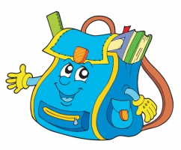
1 box of 20 Large ZIPLOC BRAND plastic bags
2 boxes of tissues (Kleenex or any brand)
2 large containers of Lysol (or similar) Disinfectant Wipes

Please send in all items with your child within the first two days of school . PLEASE LABEL ALL of your child’s clothing/belongings so that they can be easily identified if they are left behind or misplaced.

Thank you so much for your cooperation and we look forward to meeting you all on the first day!
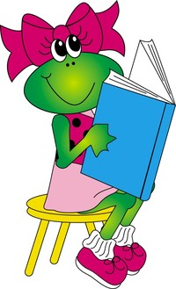
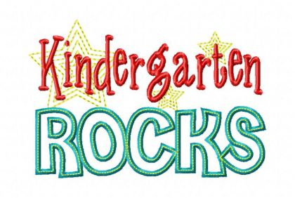

Sincerely,
The Kindergarten Teachers

