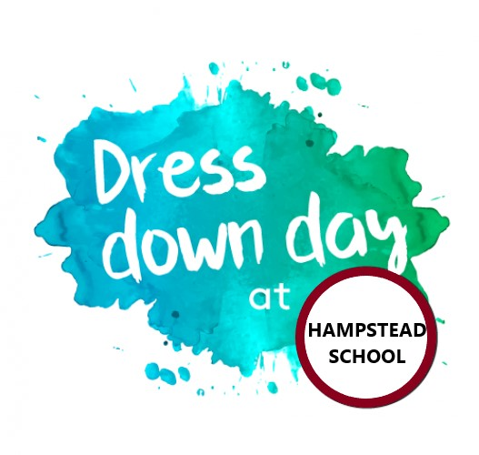

NO NEED FOR UNIFORMS
Once a month, from March to June, students will have the opportunity to wear non-uniform clothing for a $2.00 donation on each dress down day. They are free to wear anything they like, so long it fits the school setting. For safety reasons, please ensure your child wear an outfit that does not support violence. For girls’ safety, please leave high heels at home.
Students who do not bring in the $2.00 donation on Dress Down Day must wear the school uniform.
As a reminder, the school uniform includes the following: the grey or burgundy polo, t-shirt or zip-up sweatshirt paired with solid grey dress pants or dress skirt, grey jogging pants, burgundy track pants, or burgundy gym shorts. Jeans are not permitted! All clothing should be plain and free from any logos, unless it is Hampstead School’s logo.
.
Mark your calendars!
Dress Down Day will take place on the following dates:
MARCH 27
APRIL 24
MAY 22
JUNE 12
Please bring in the $2.00 donation on those days. Otherwise, students must wear their uniforms!

For questions, please contact Ms. Ariella Pardo at ppohampstead@gmail.com

